ASSIGNMENT-VPC  
  
i) Create the VPC and create two subnets as private and public subnets  
ii) Provide the internet connection to VPC  
iii) Create the RT and attach to the public subnet and IGW  
iv) Create virtual machines in two subnets with Bootstrap Script for installing httpd  
v) access the virtual machines and check for its output   
  
Creation of vpc  
  
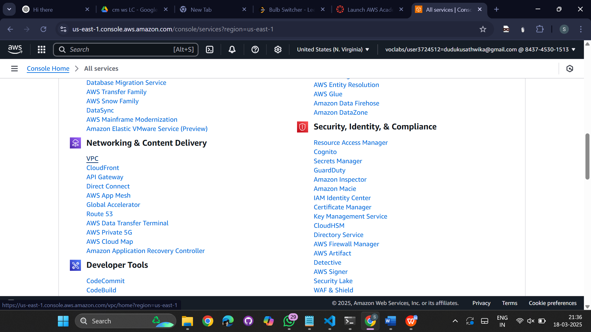

Create VPC ( MyVPC ) -   
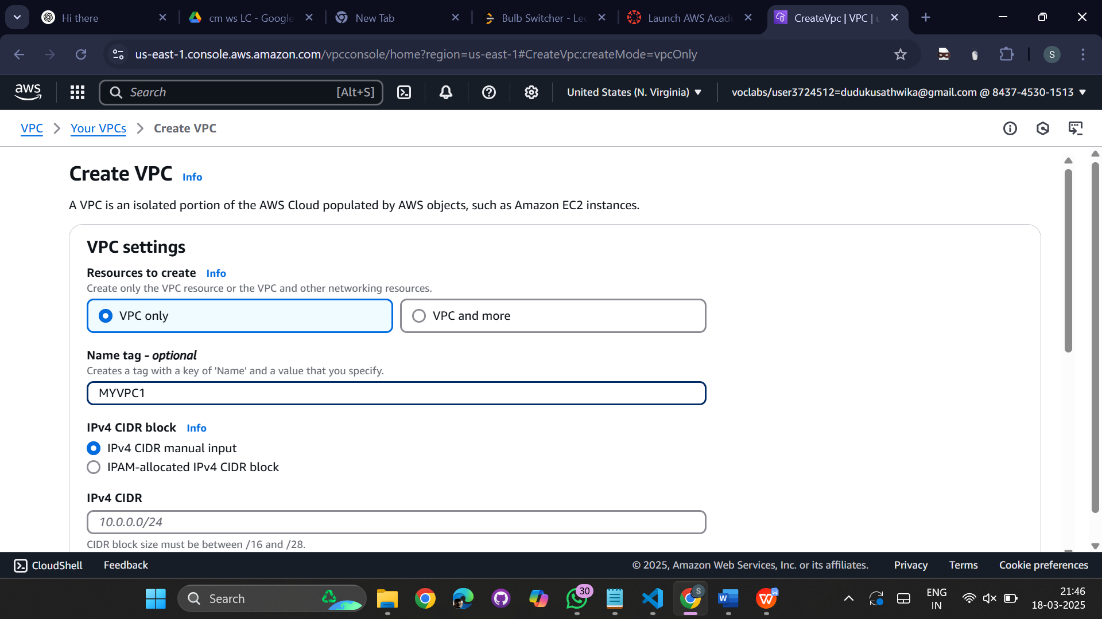

Provide ipv4 CIDR -10.0.0.0/16  
  
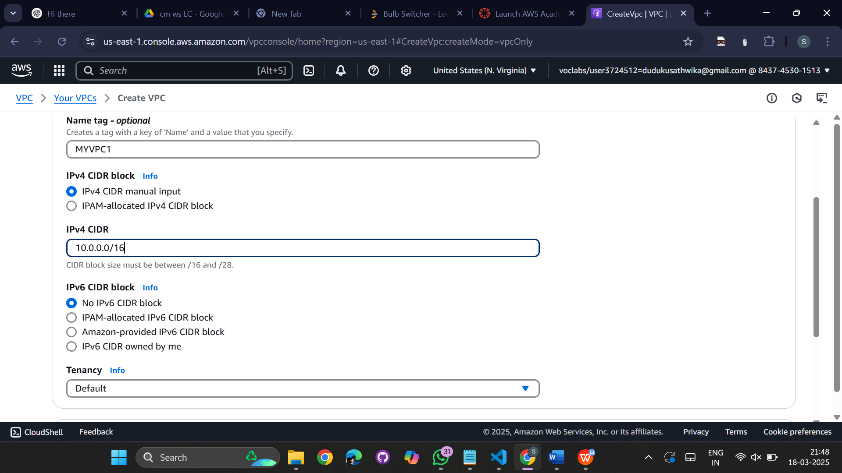  
  
successfully vpc created   
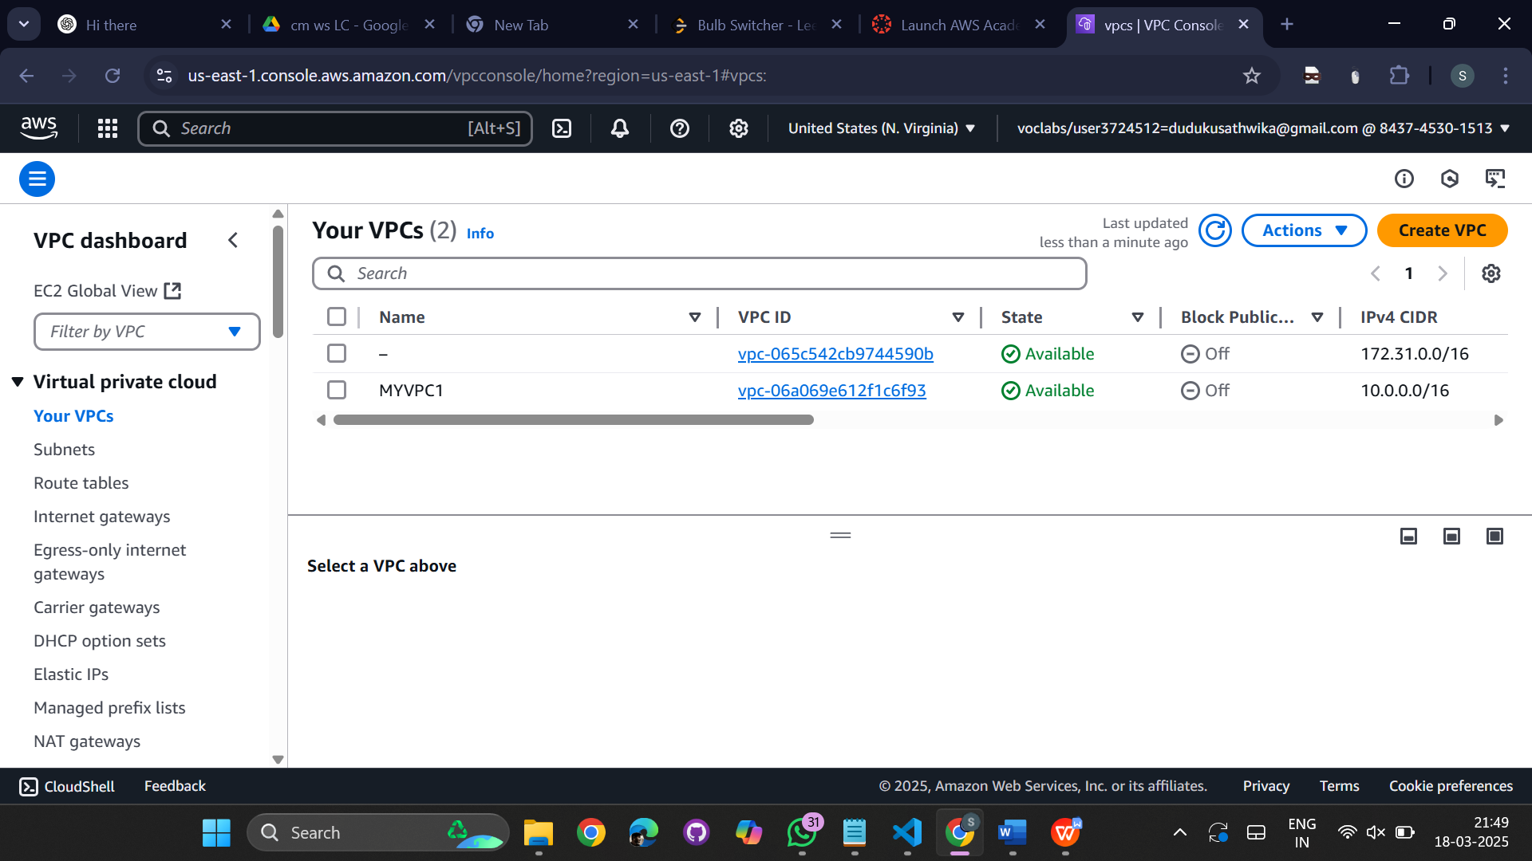  
  
  
  
  
  
  
  
  
  
  
create two subnets:  
1st subnet:   
subnet1 - 10.0.1.0/24 - Web-Server  
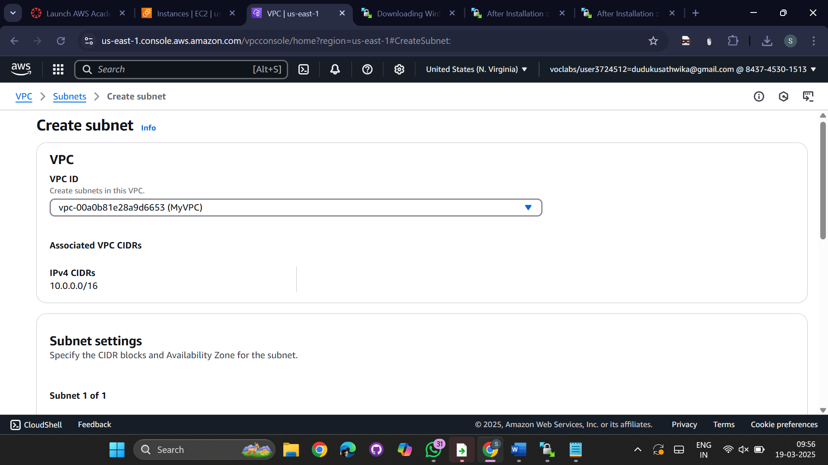  
  
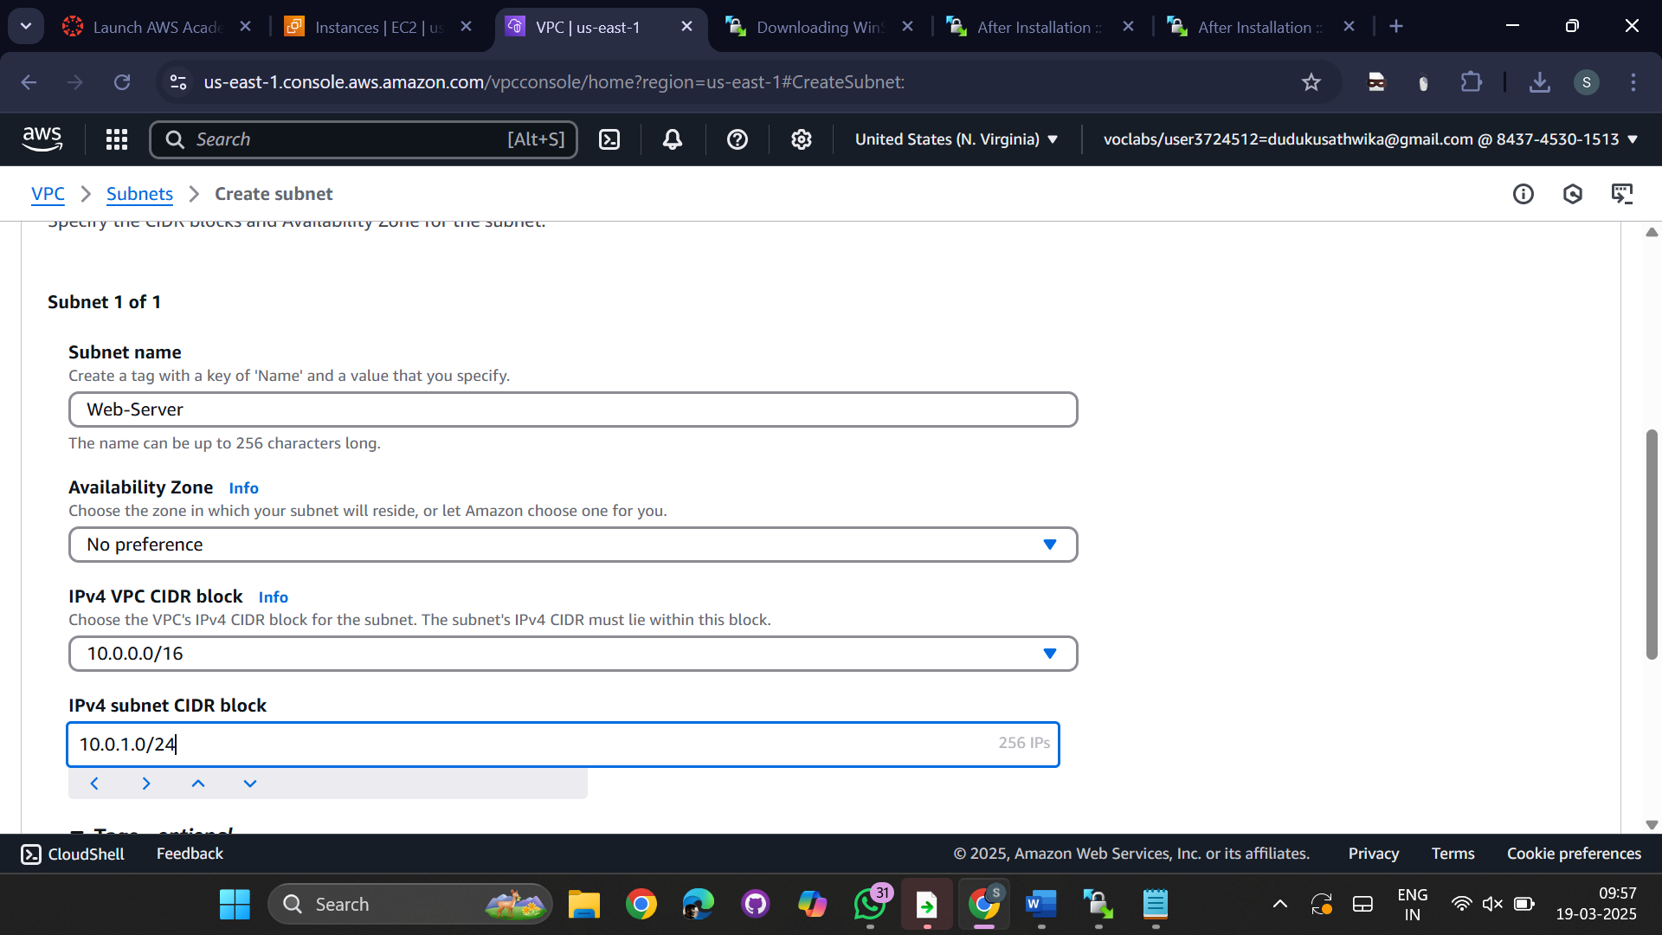  
  
subnet2 - 10.0.2.0/24 - Db-Server  
  
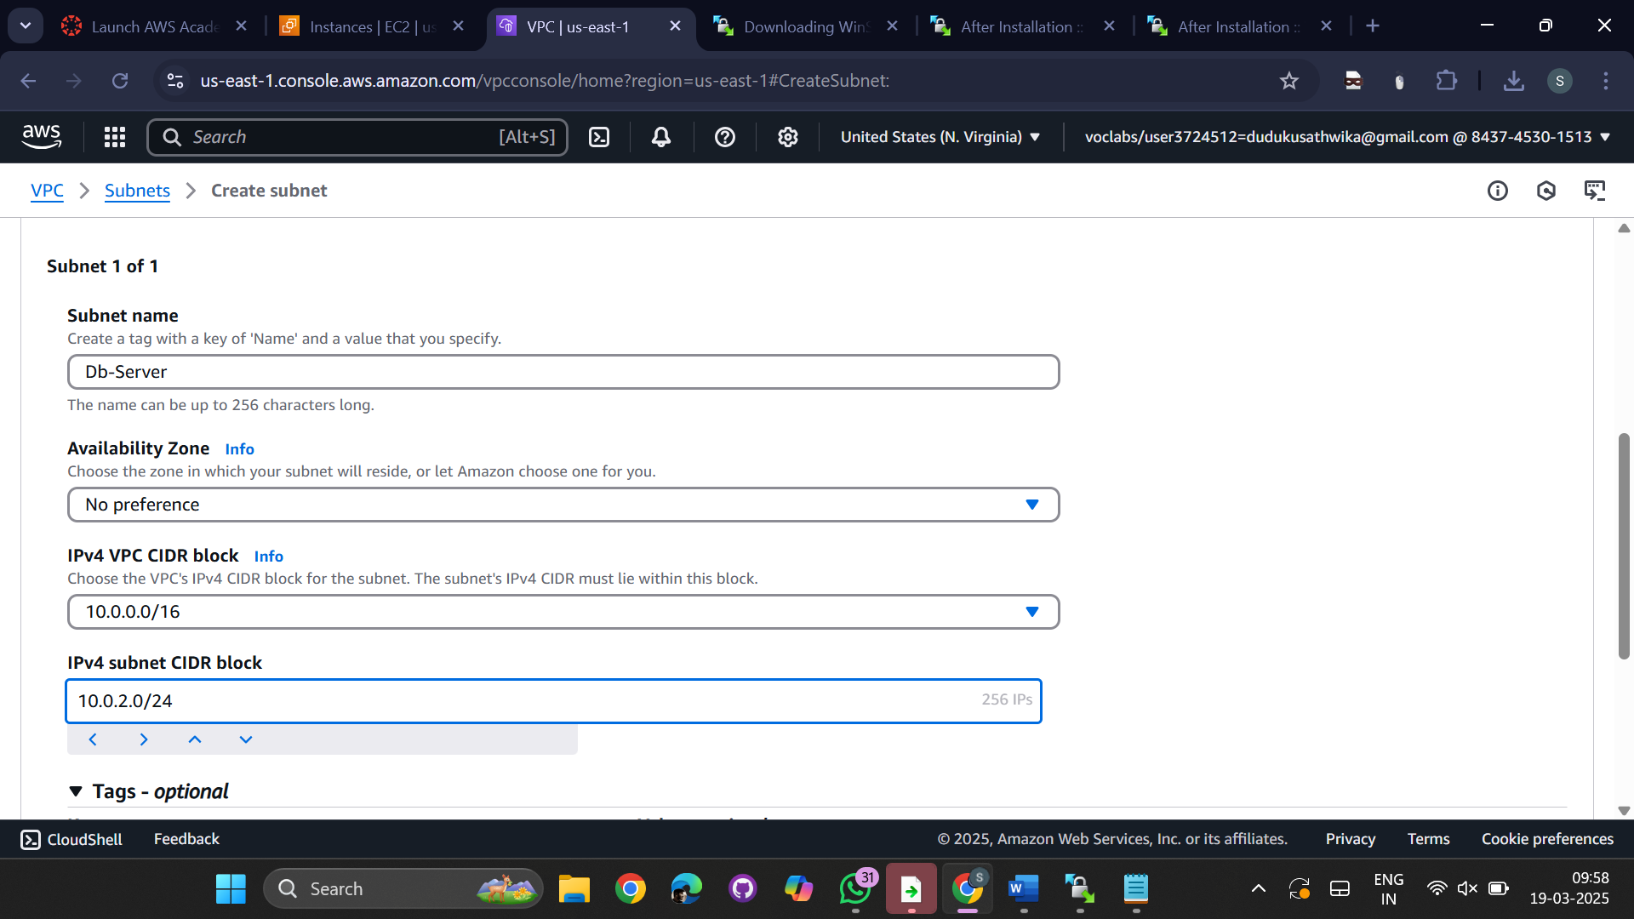  
  
Enable public IP to subnet1  
  
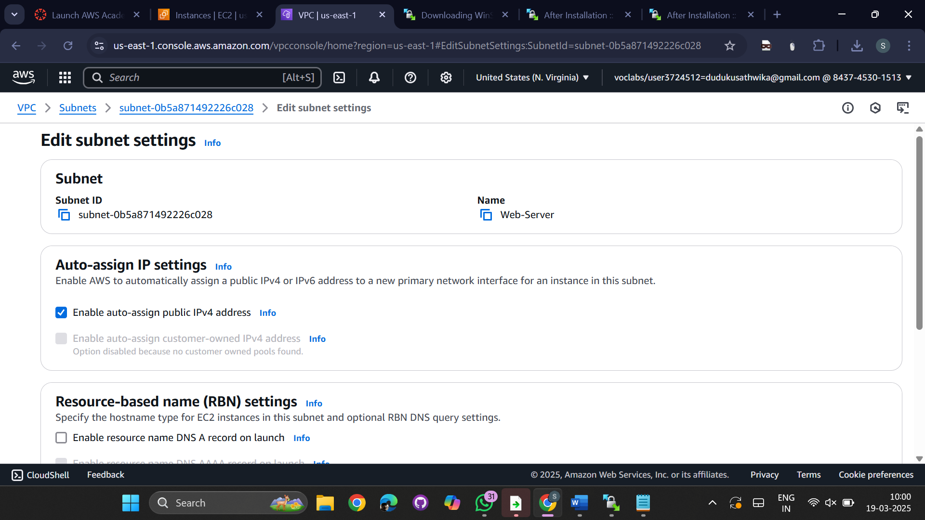  
  
Create Internet Gateway attach to VPC -- MyIGW  
  
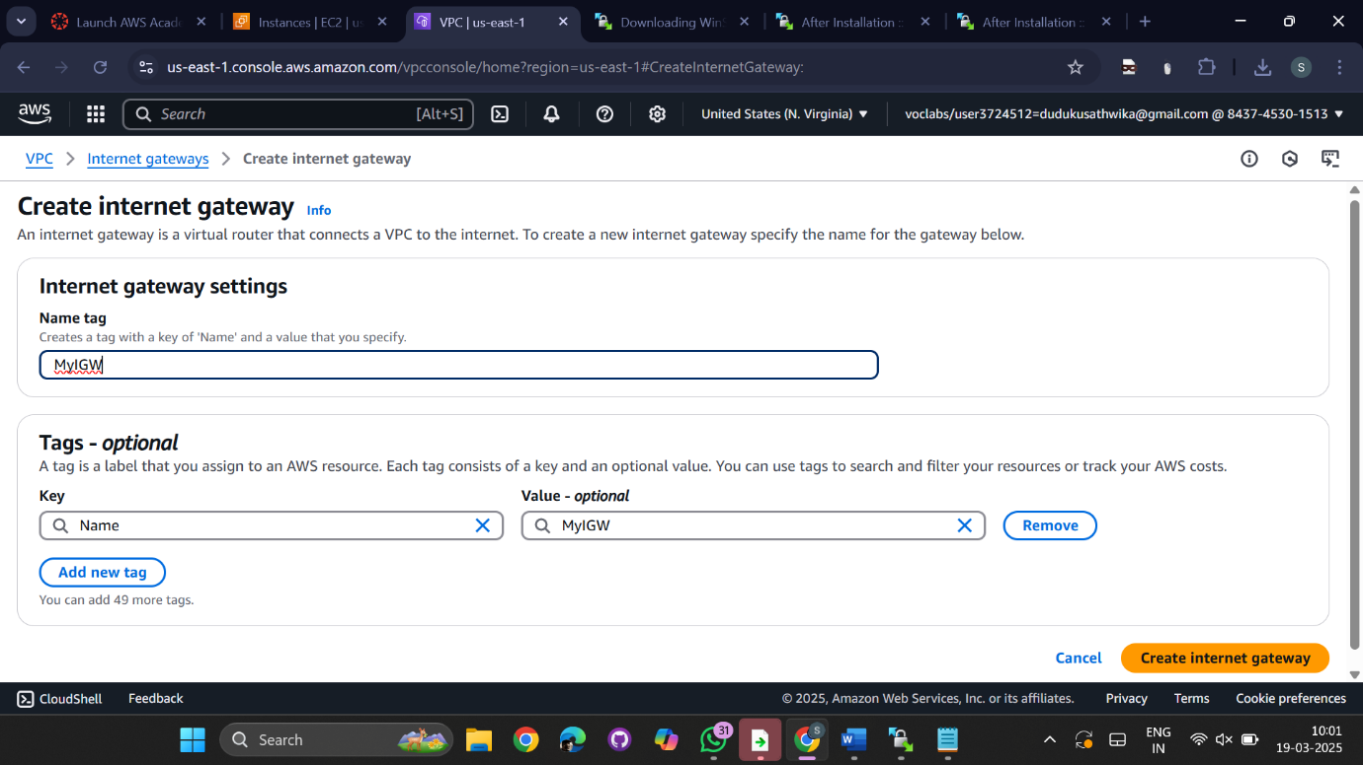  
  
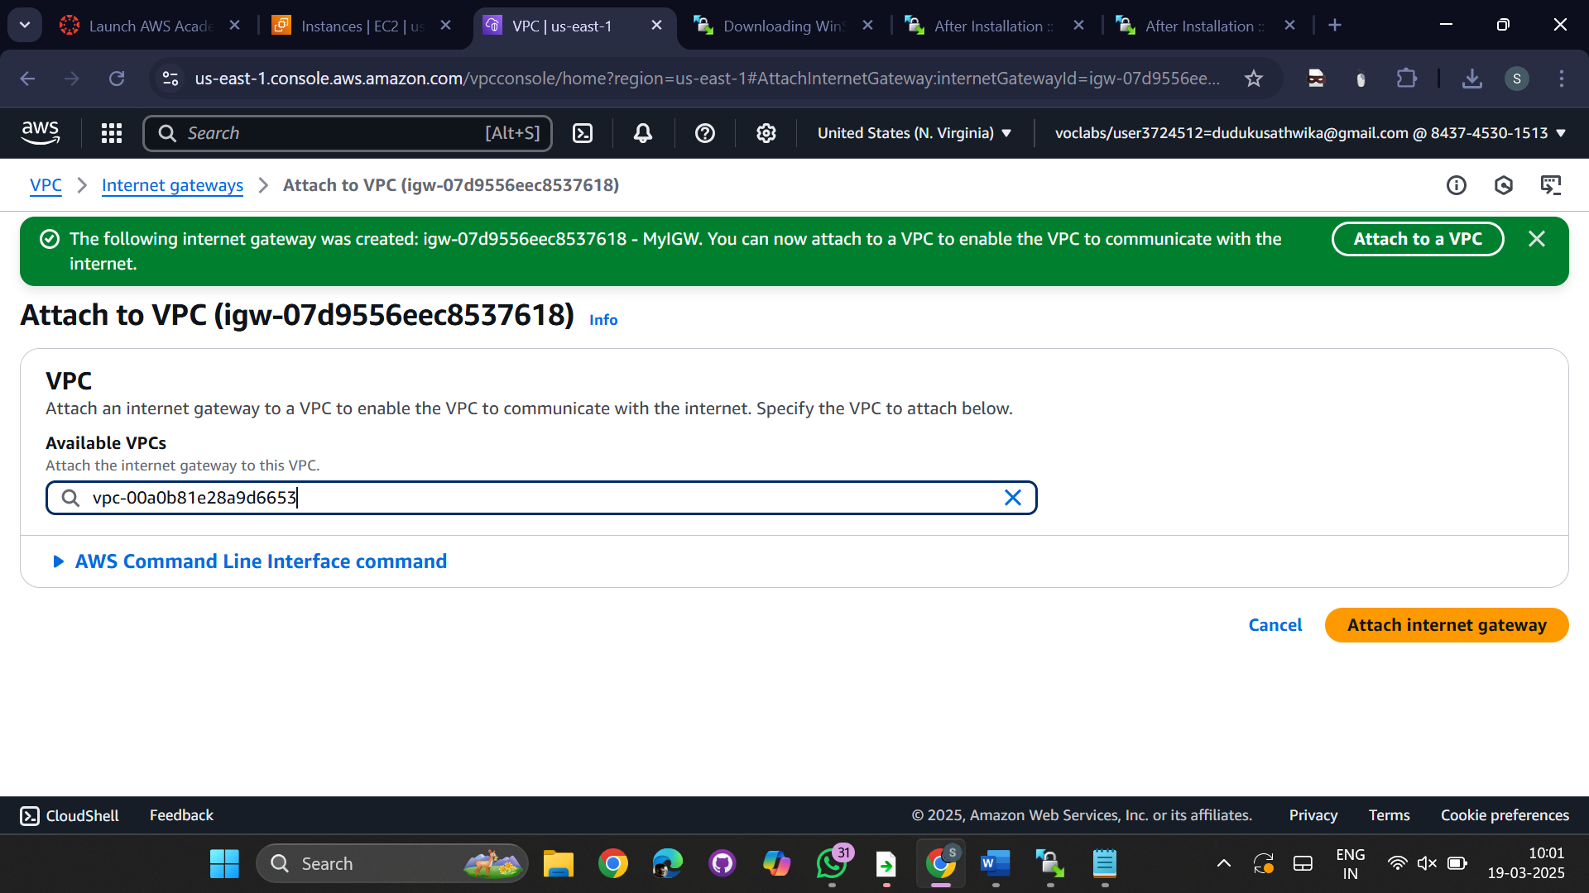  
  
Create Route table -- InternetRT  
  
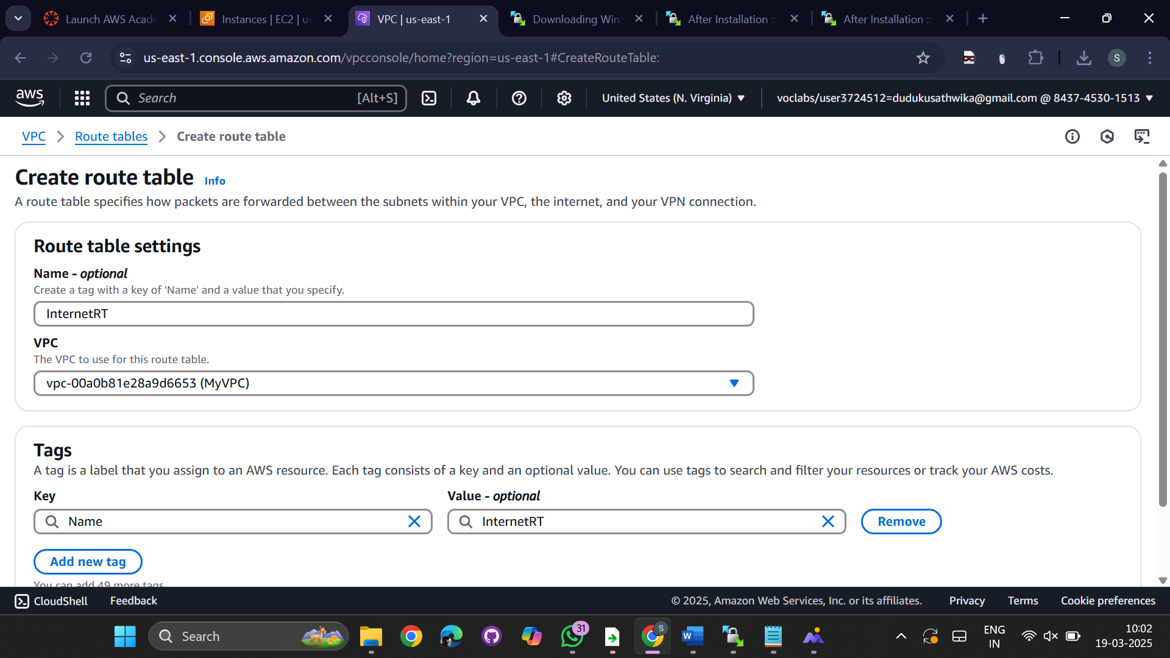  
  
Attach Route table to subnet1  
go to actions->edit subnet associations  
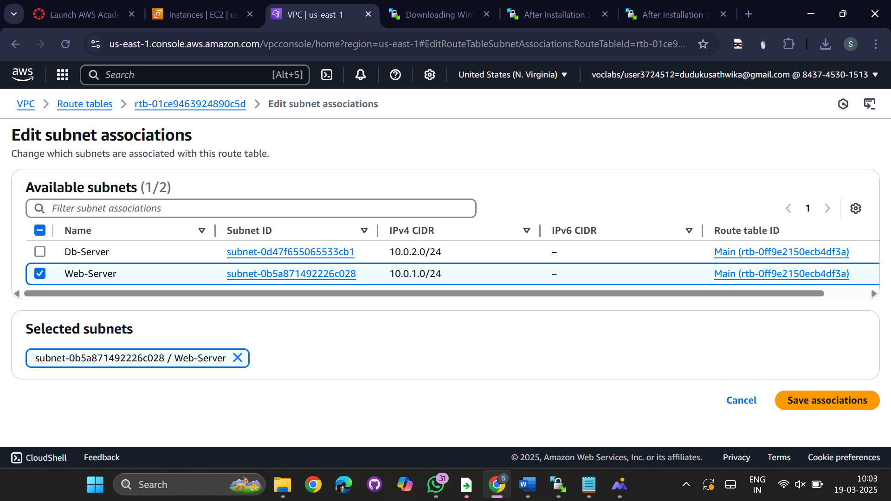  
  
Attach Route table to Internet Gateway  
  
go to actions->edit routes  
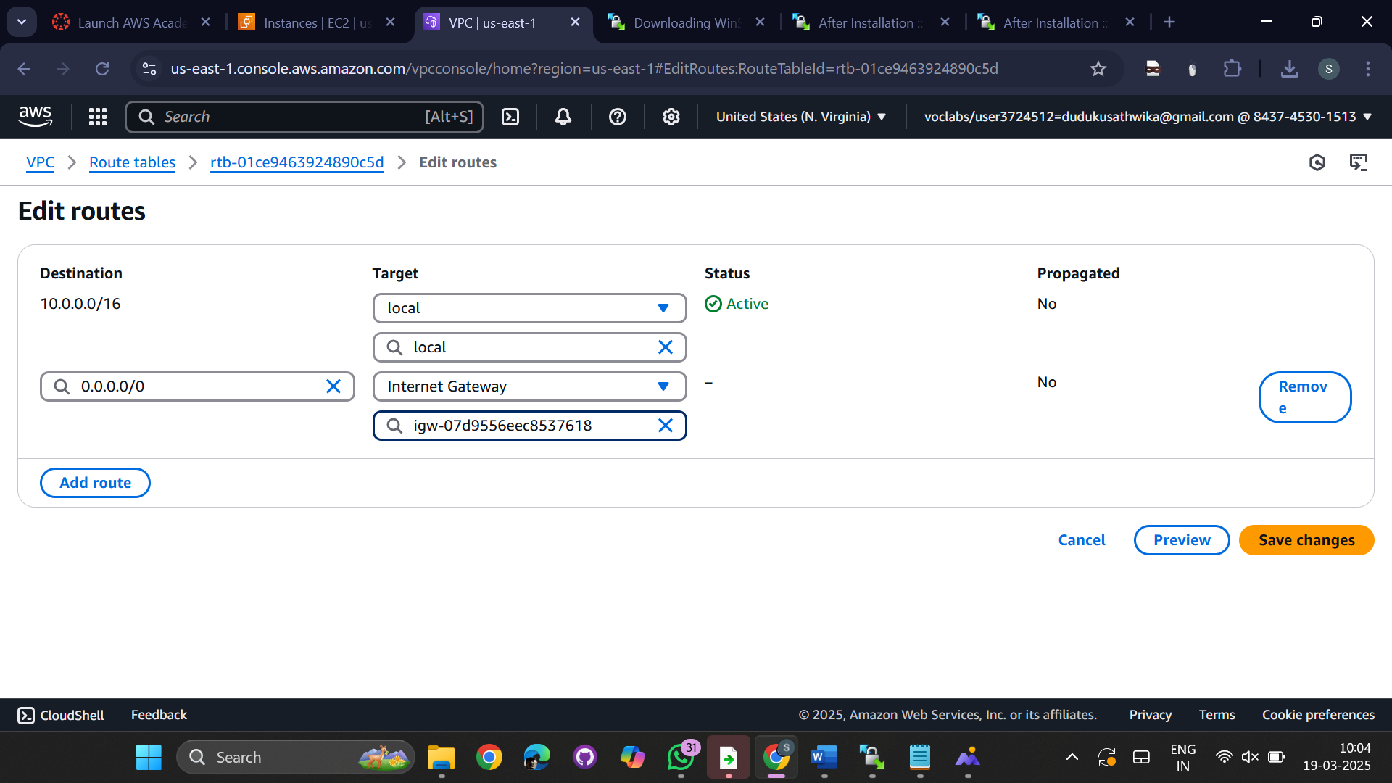  
  
  
Now, Lets launch web-server in public subnet.

Services ---Ec2 ---- Launch instance --

Name : WebServer

AMI : linux

keypair : webKP30.pem

Network : MyVPC  
  
  
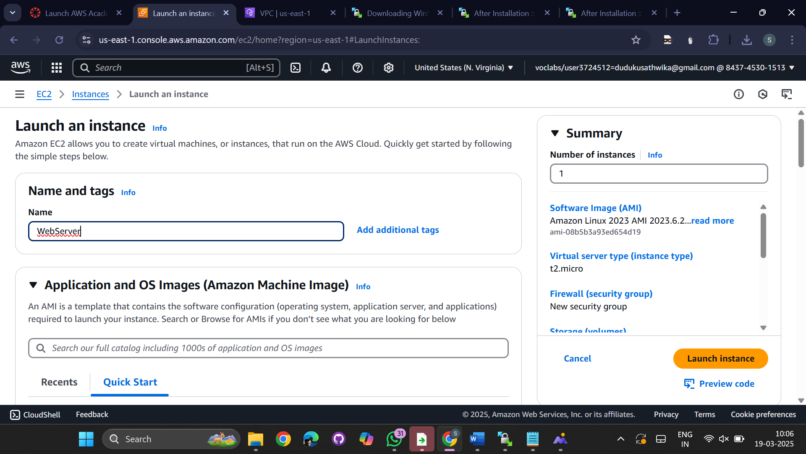  
  
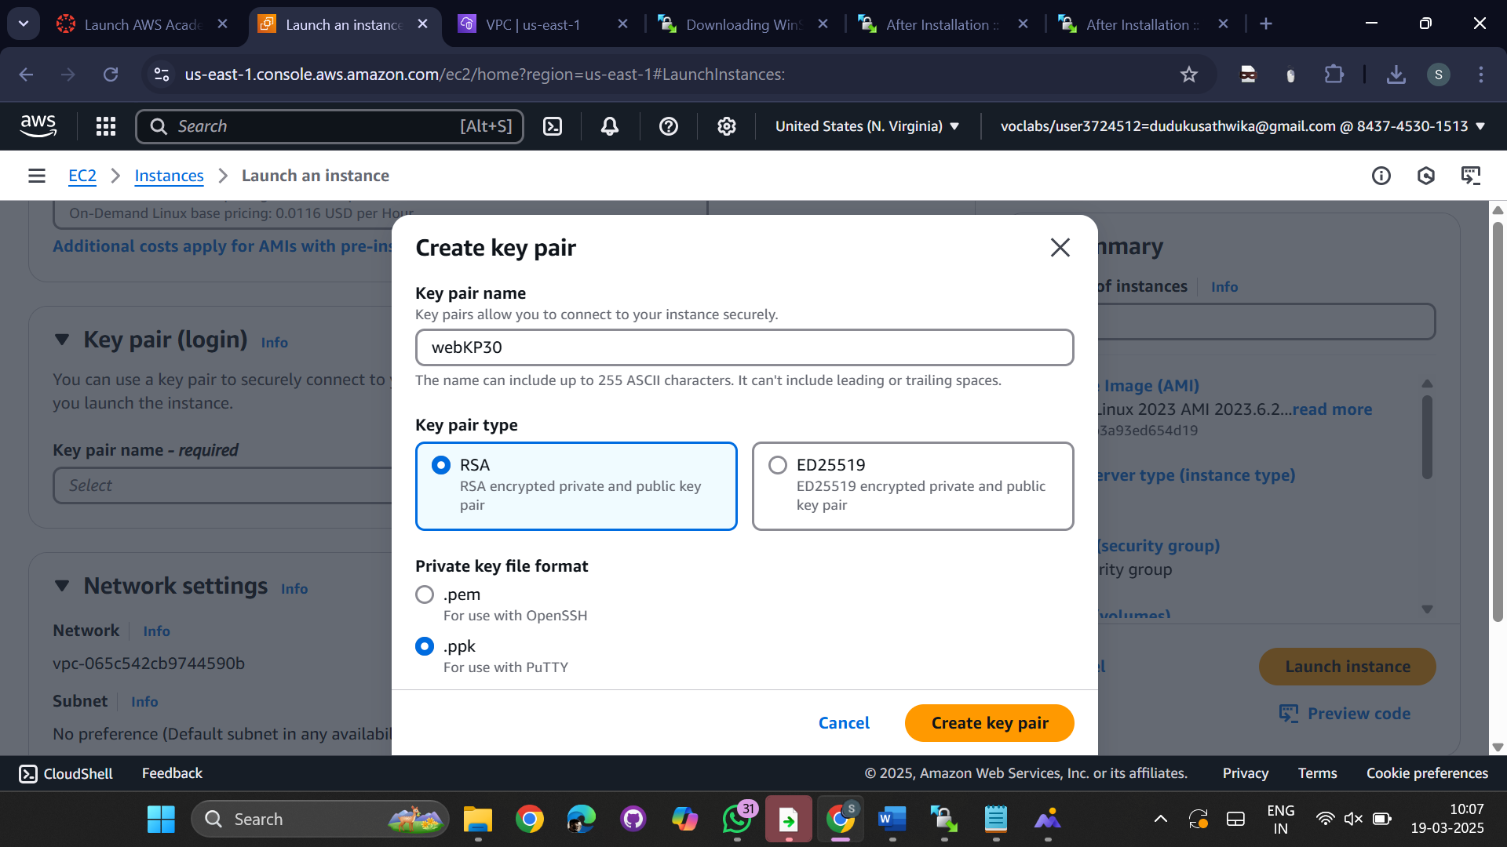  
  
Subnet: 10.0.1.0/24

Security Group : Web-SG , Description: WebSG30

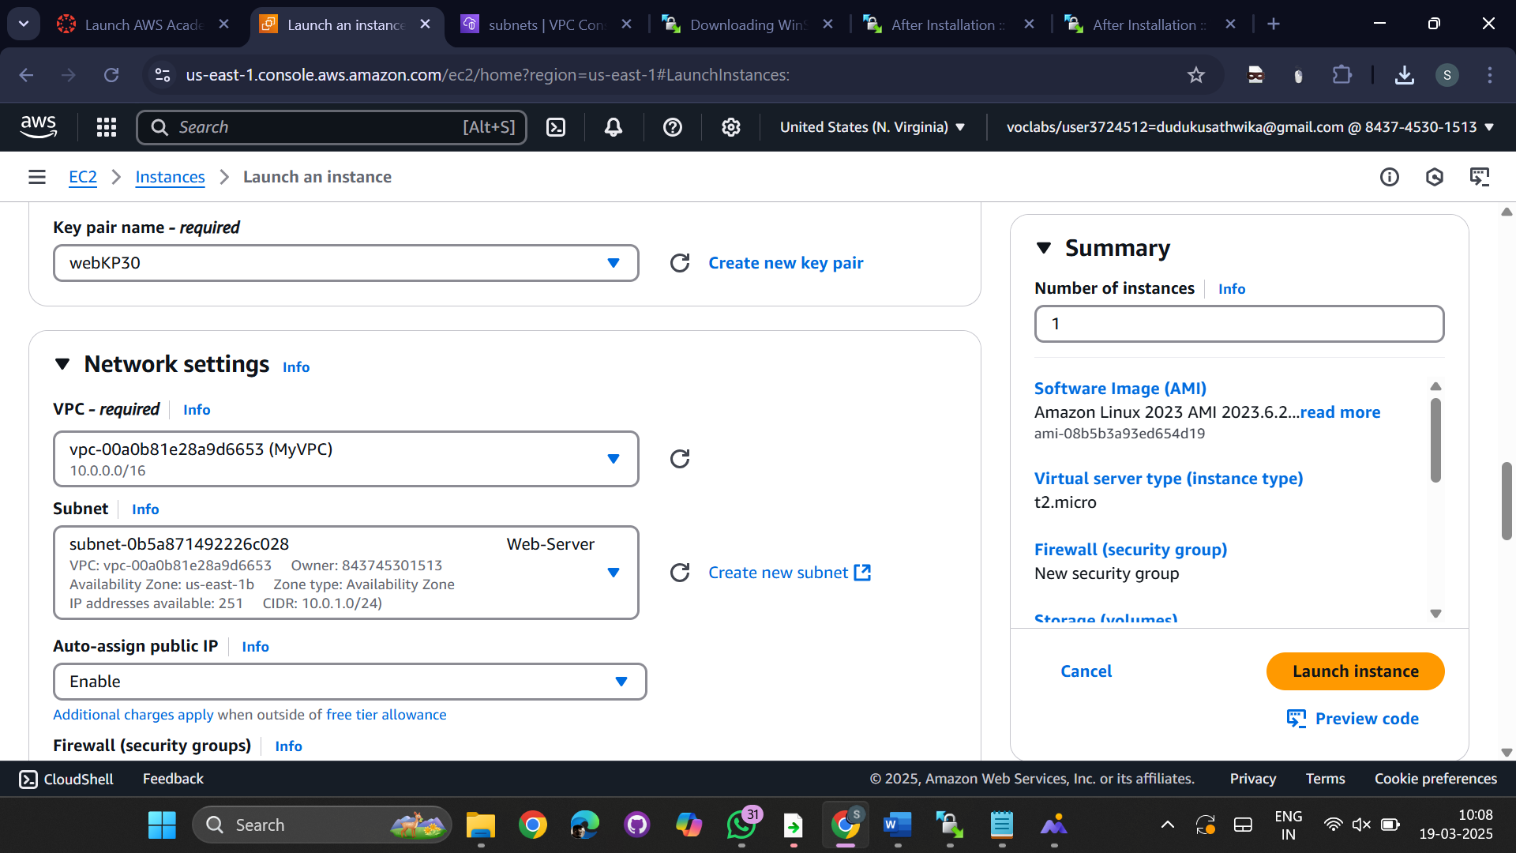  
  
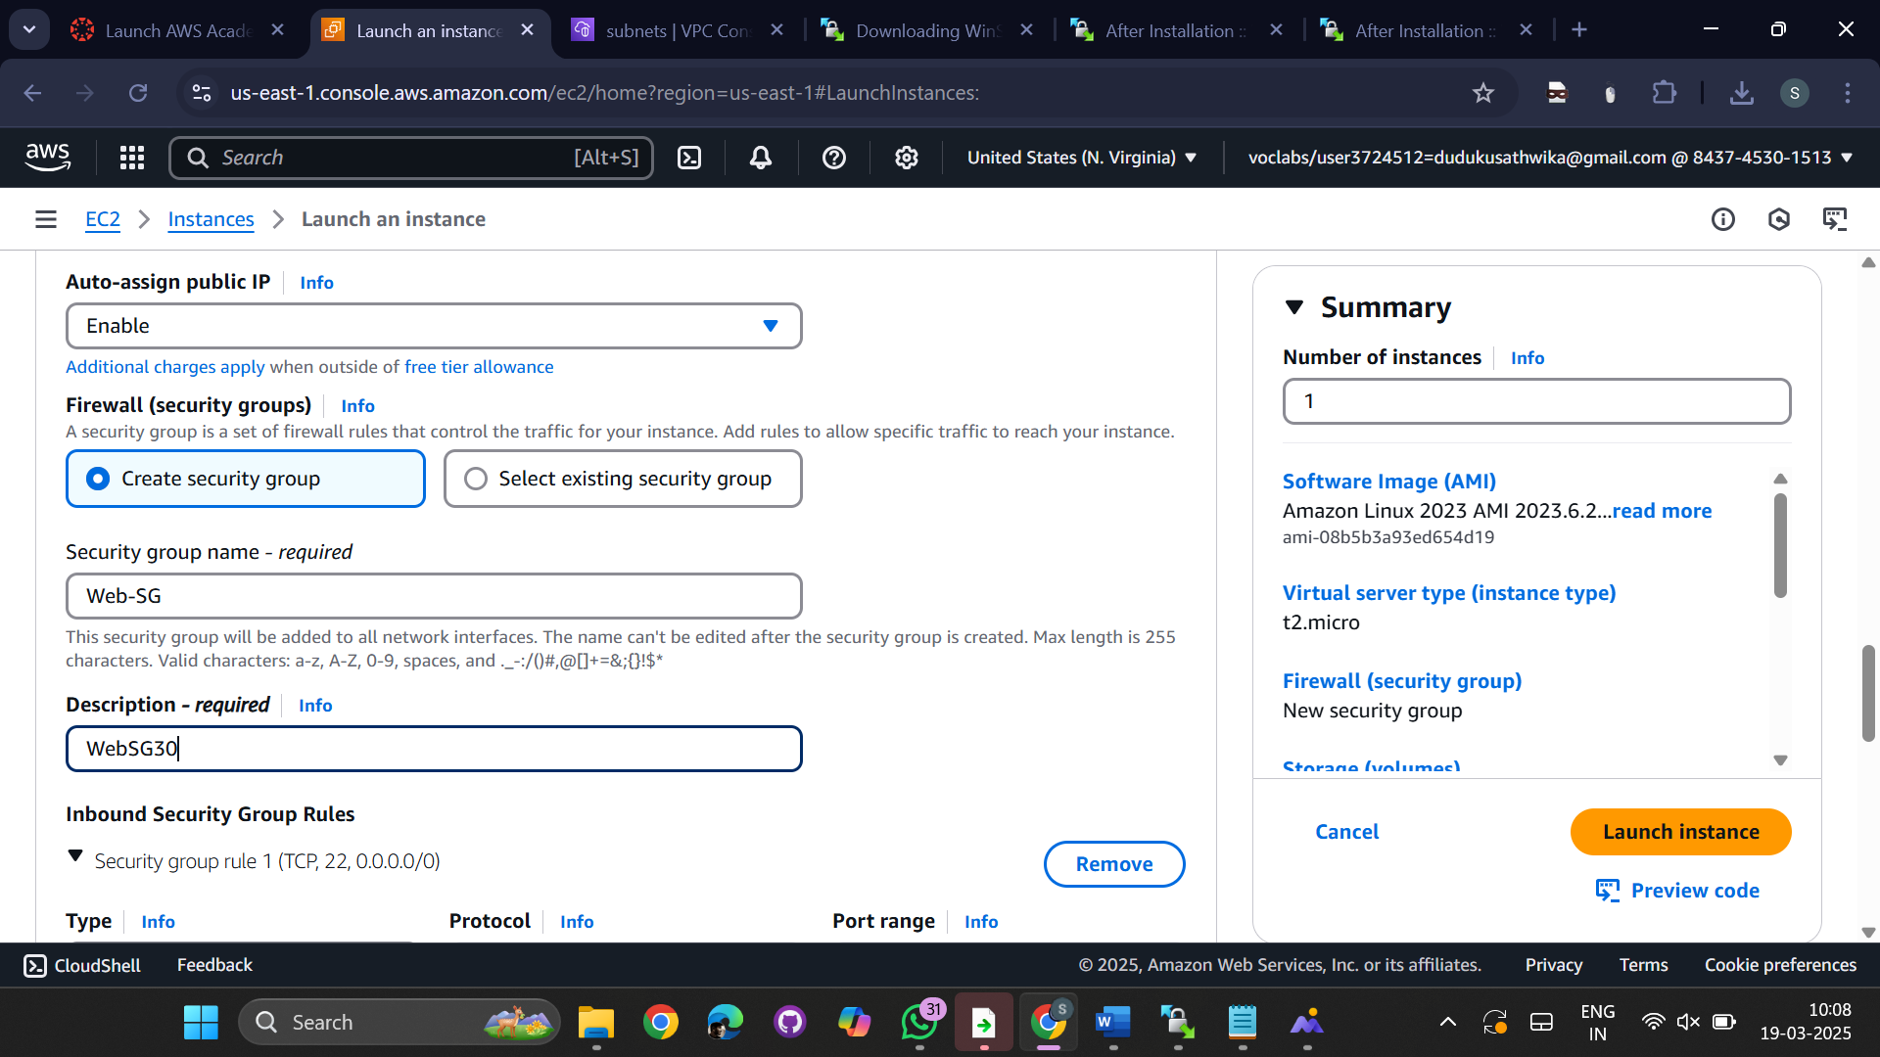  
  
ADD RULE

Type Source

SSH Anywhere

HTTP Anywhere  
  
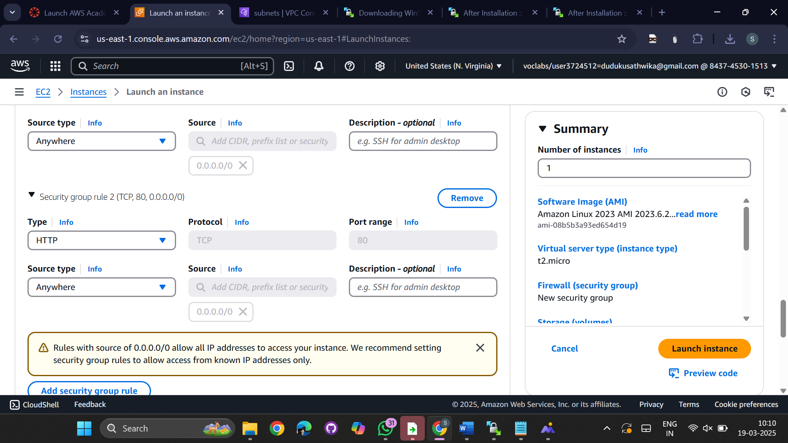  
  
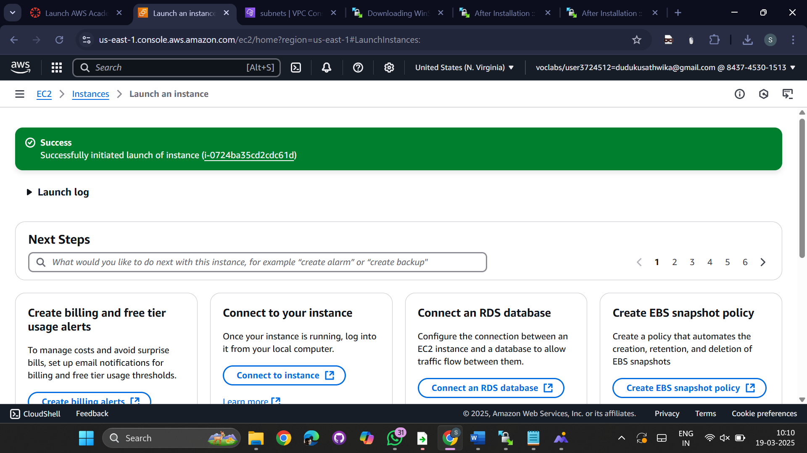  
  
  
Lets Launch Database Server in Private SUbnet.

Services ---Ec2 ---- Launch instance

Name : DbServer

AMI : Linux

Create new keypair --> (dbKP30.pem )

Network : MyVPC  
  
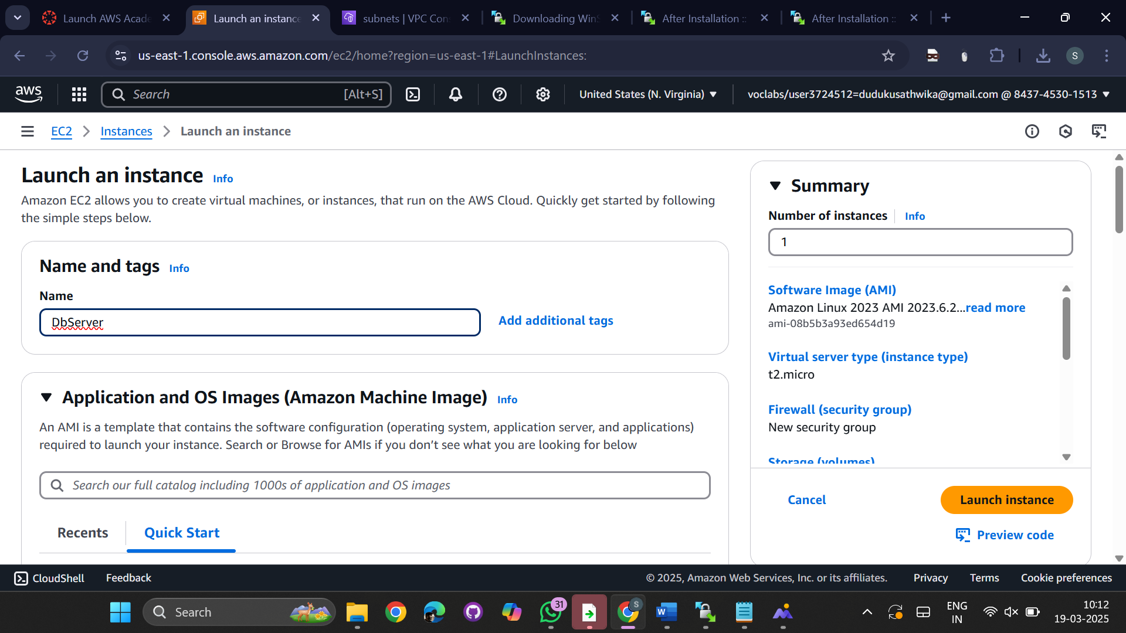  
  
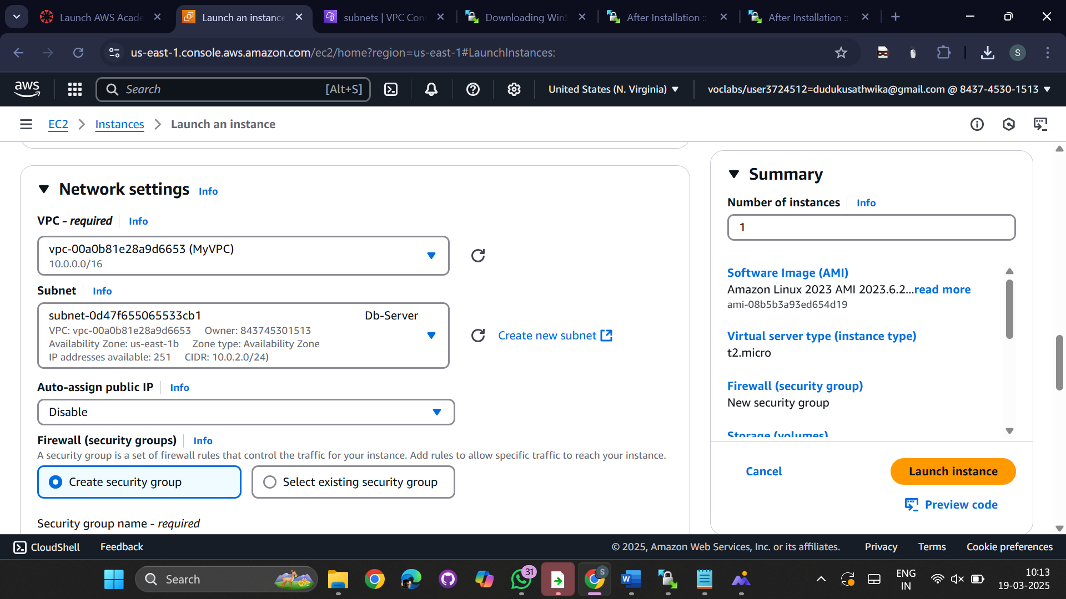  
  
Subnet: 10.0.2.0/24

Security Group : Db-SG , Description: DbSG30  
  
Change Type from SSH to MYSQL/Aurora

Type Source

MYSQL/Aurora Custom 10.0.1.0/24  
  
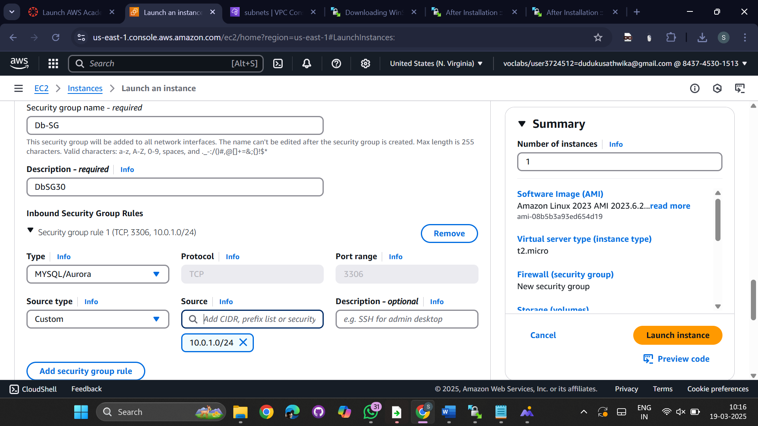  
  
go to additional details->check for user data

Paste the Bootstrap Script for installing httpd 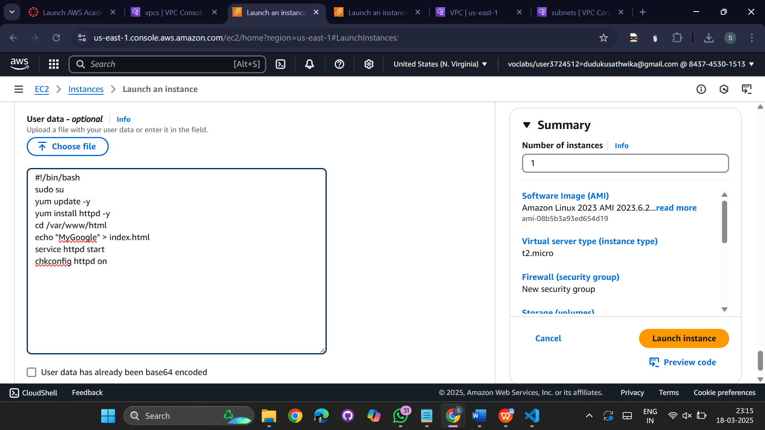  
select webserver-01 which is in public   
copy the public IPv4 address   
  
  
  
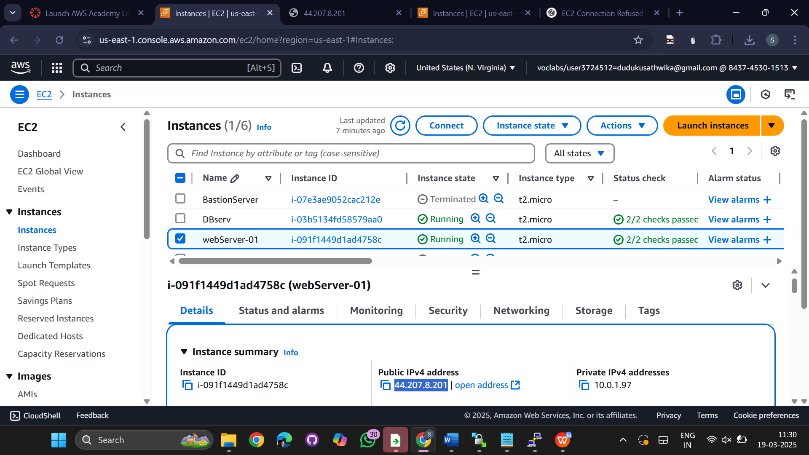  
  
paste the ipv4 address and display in the internet  
  
  
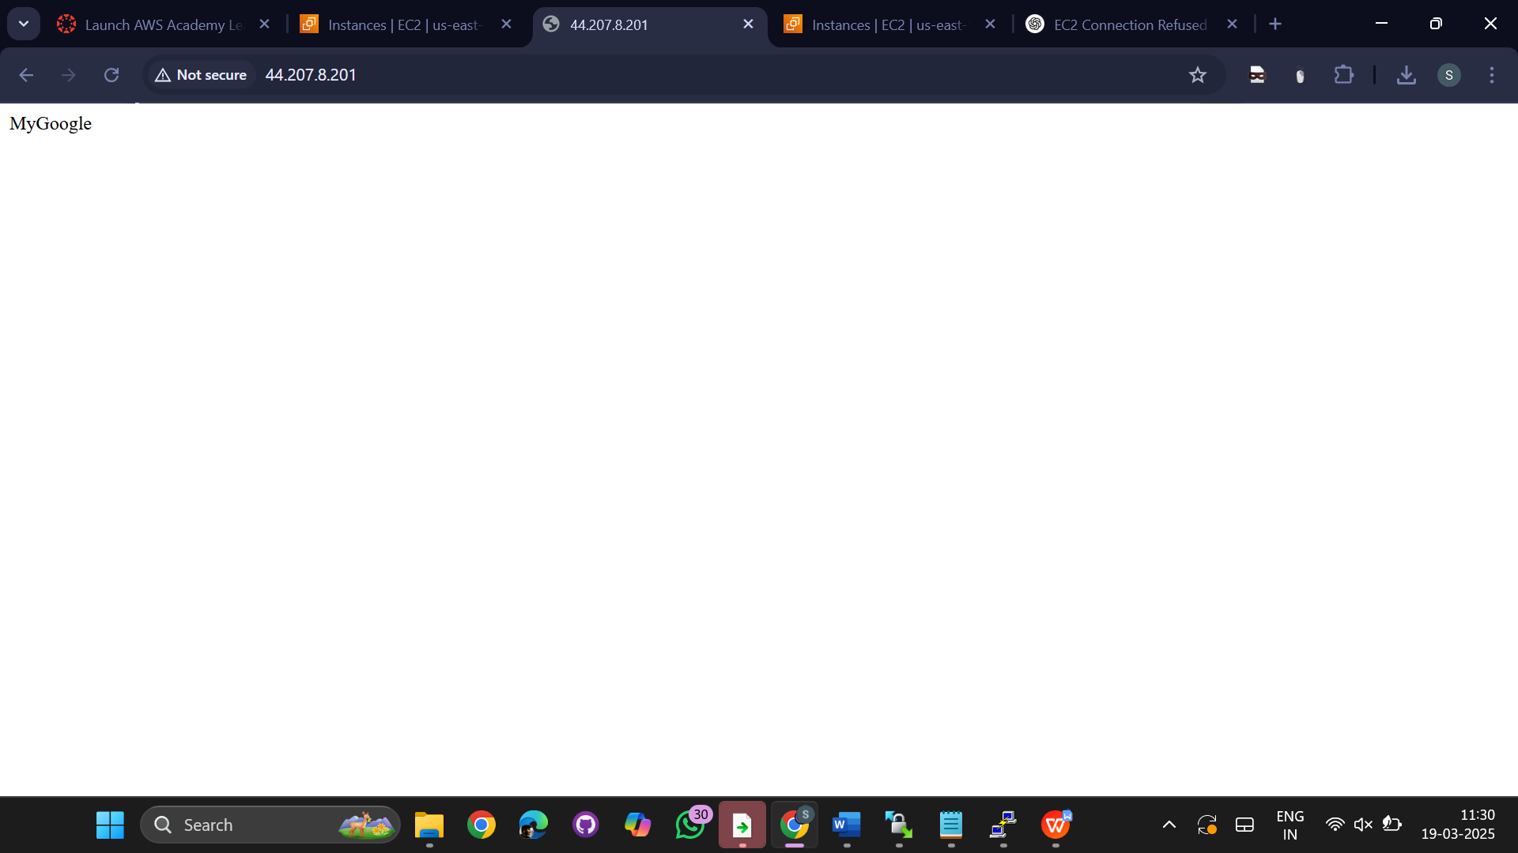

For private instance we cant display in the internet  
  
